Day 2

Java Introduction Part 2 and Flow Control Part 1

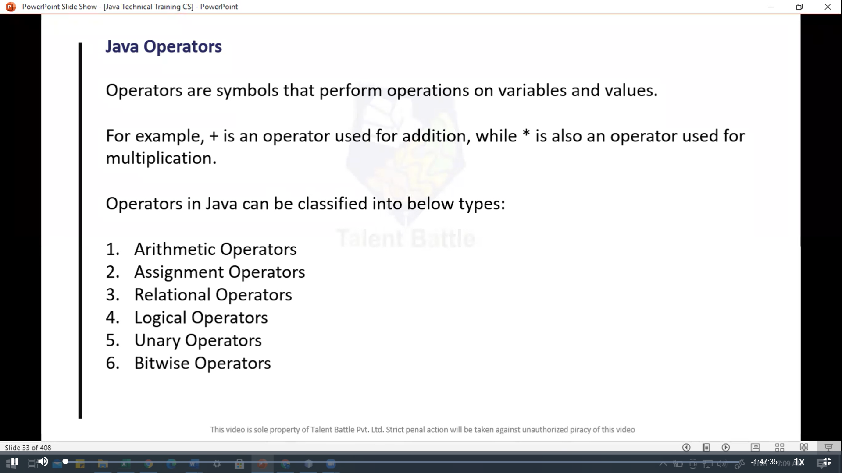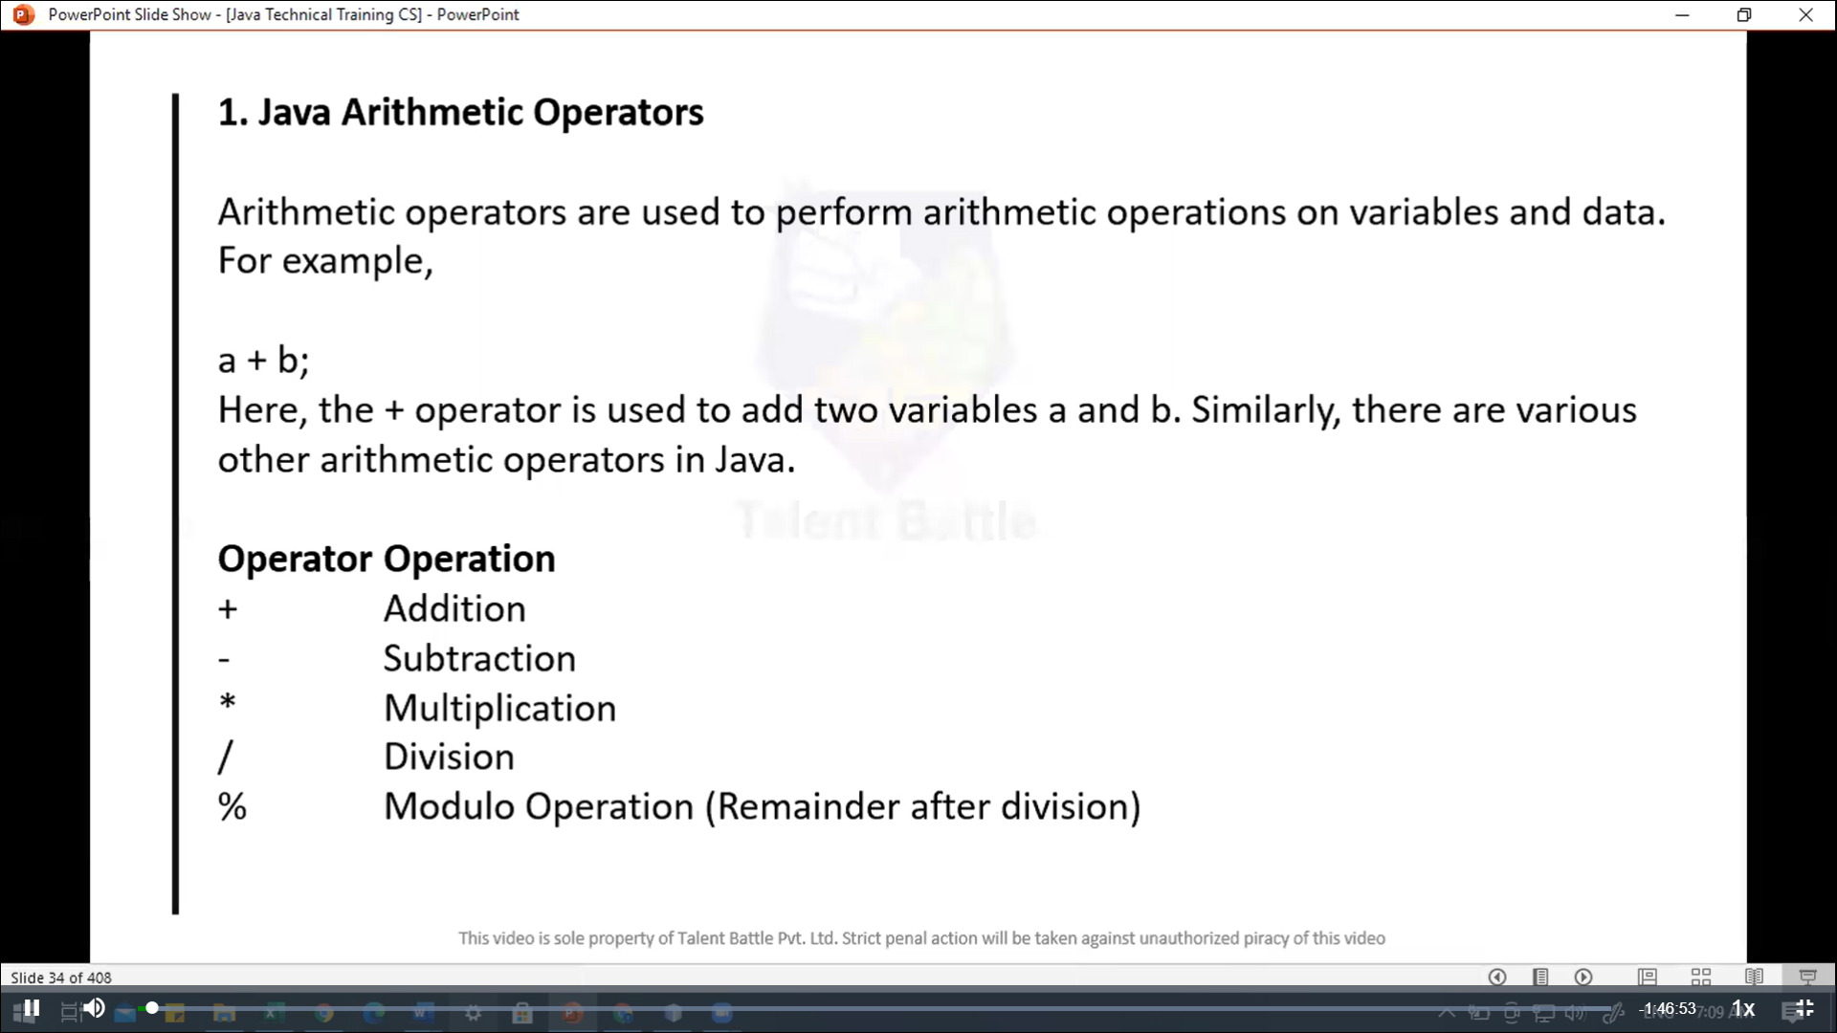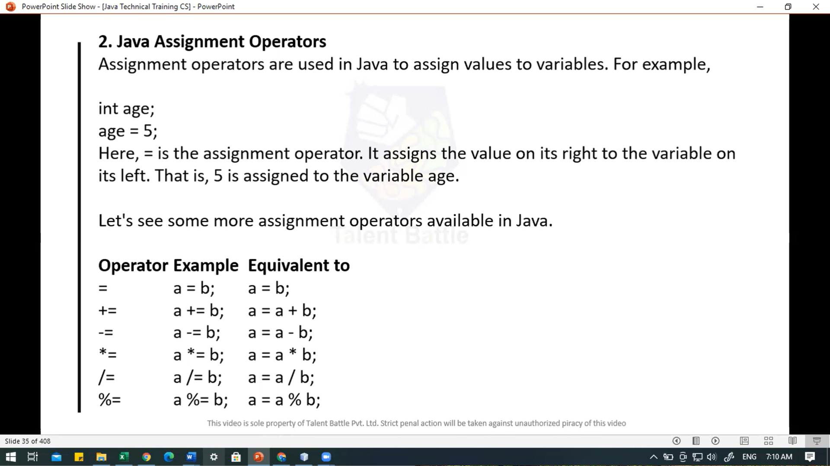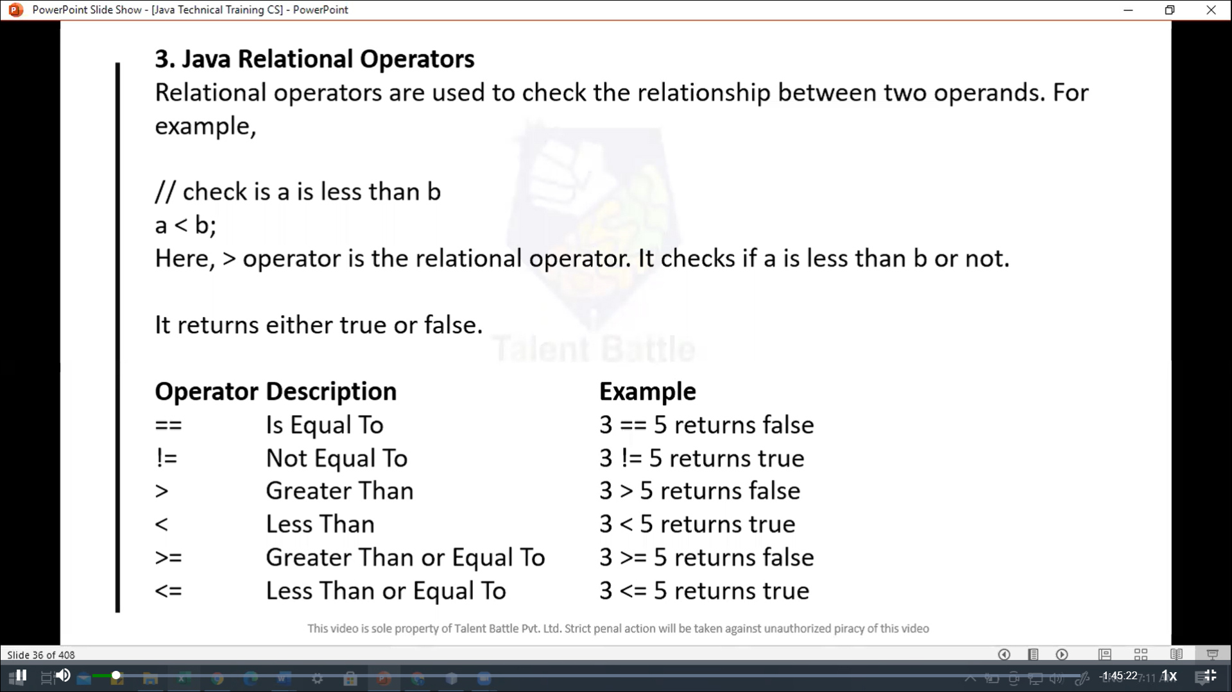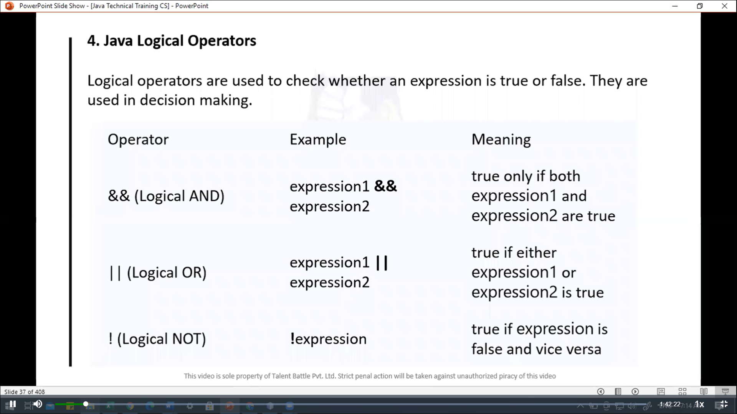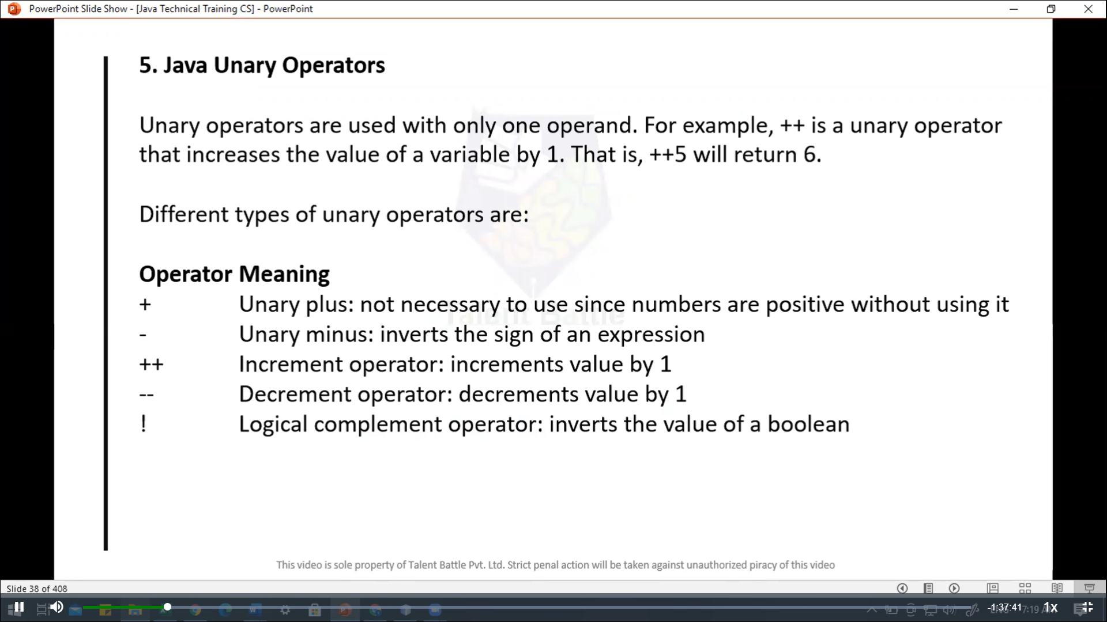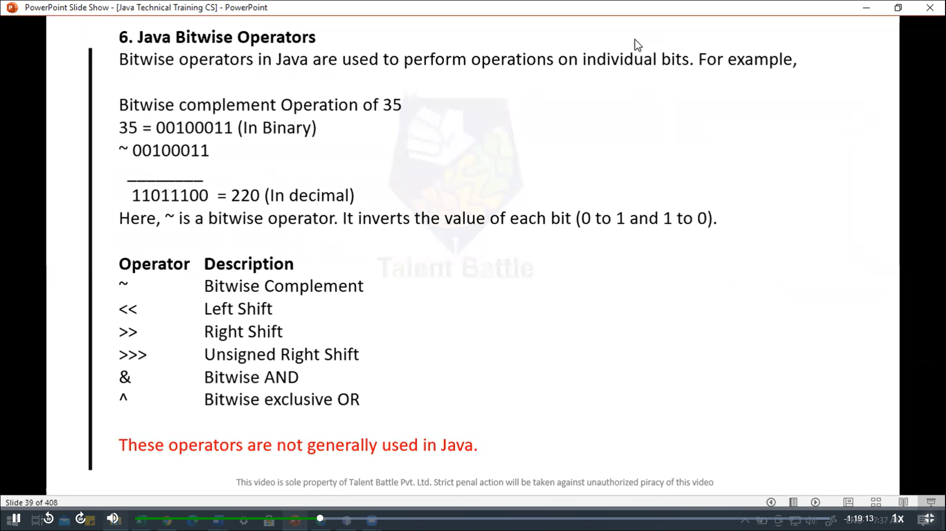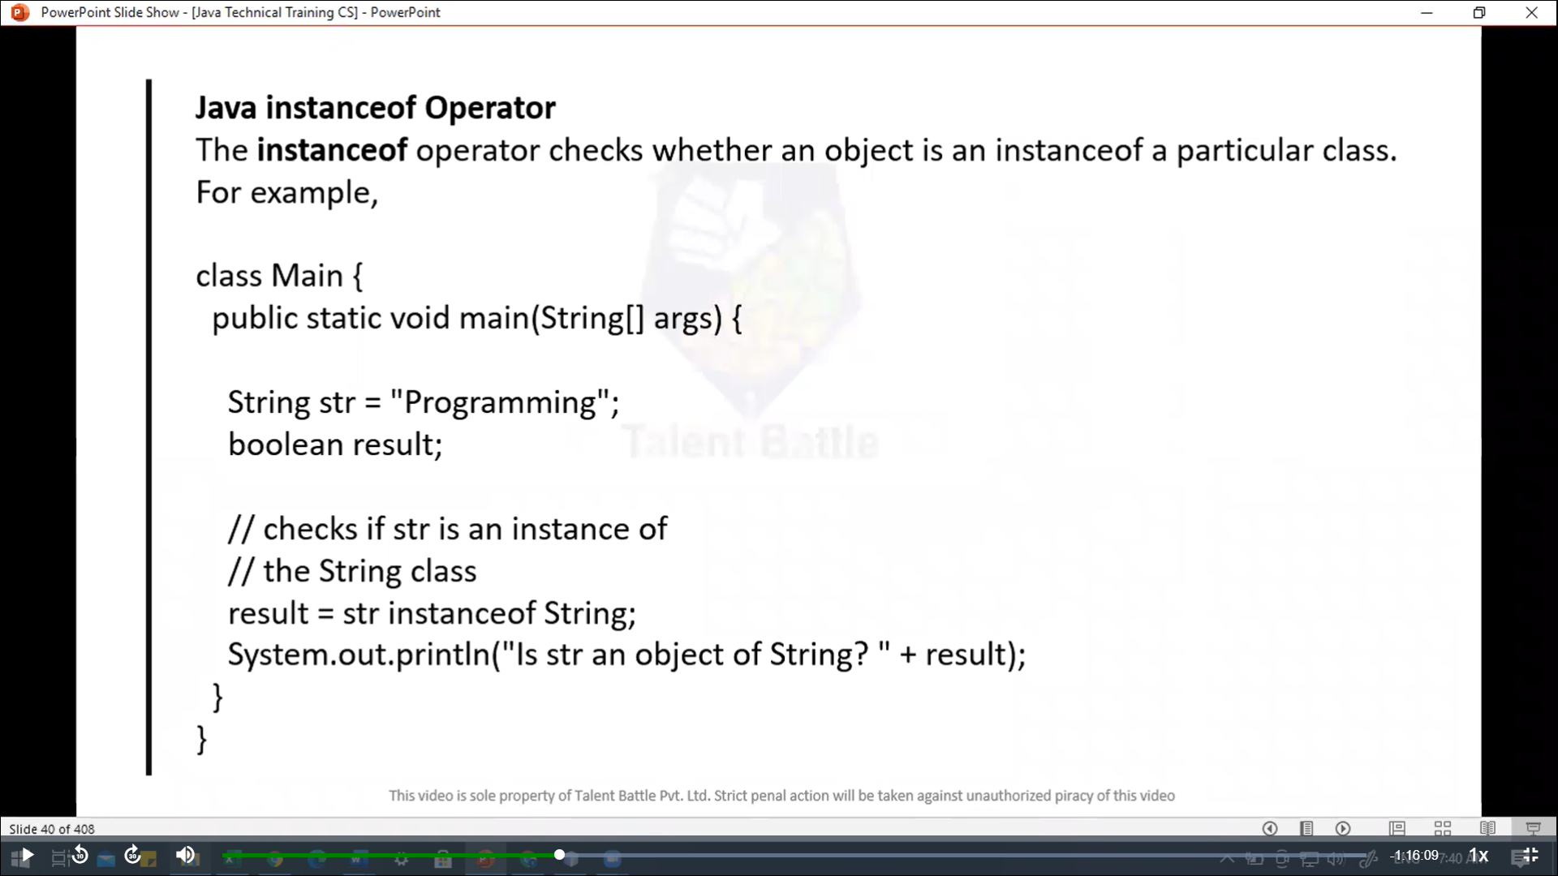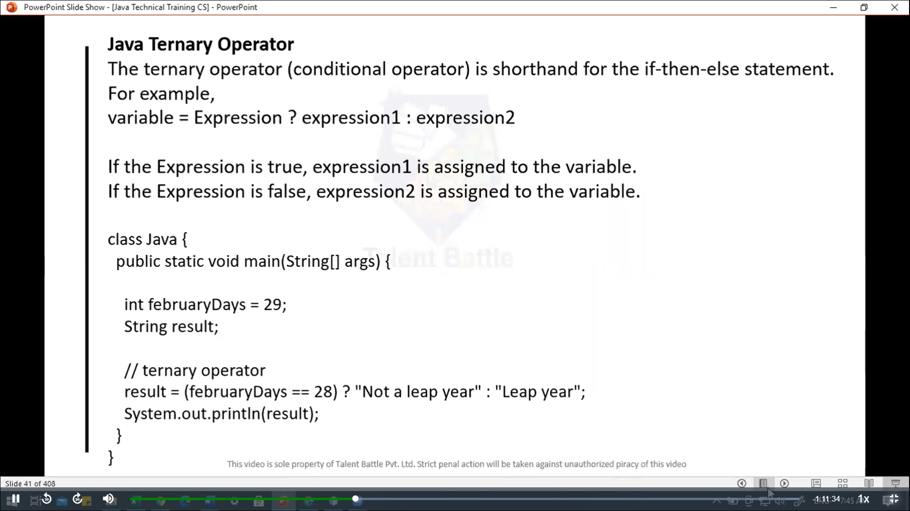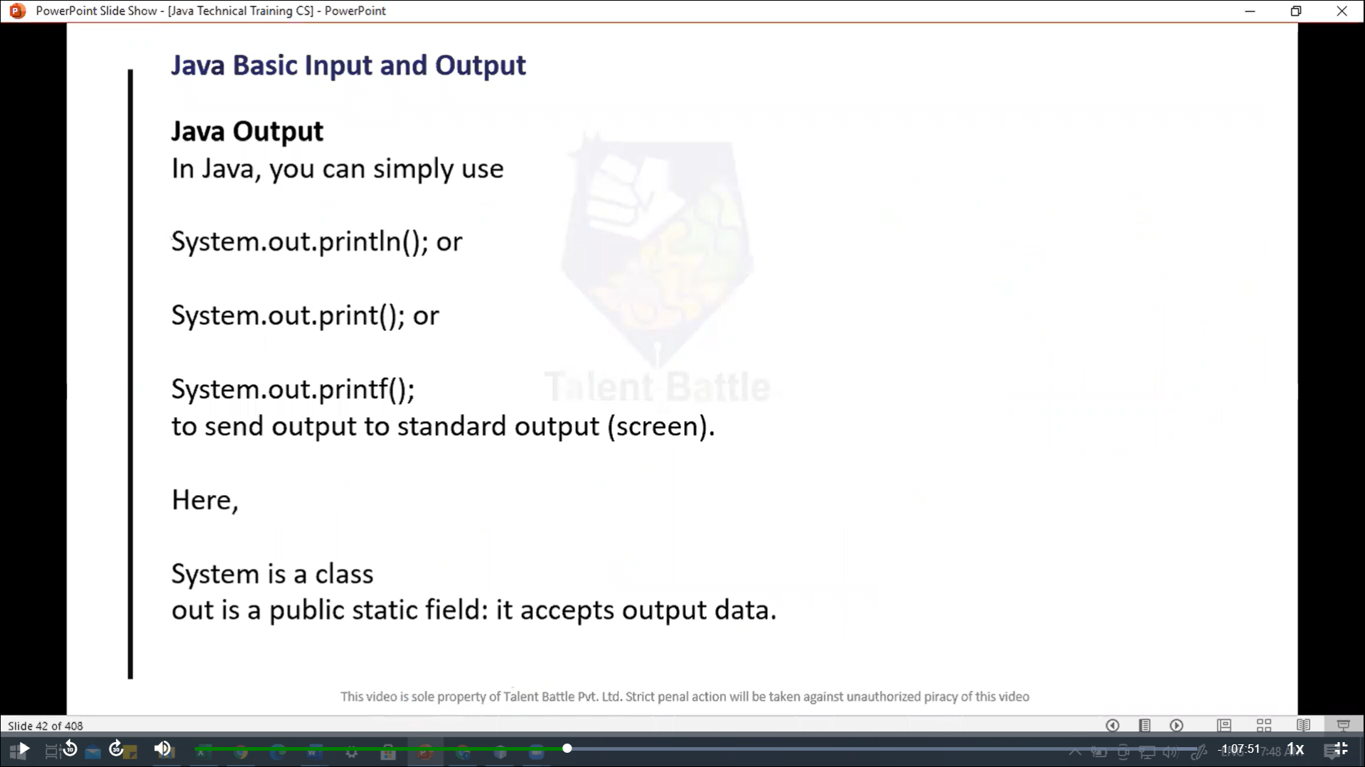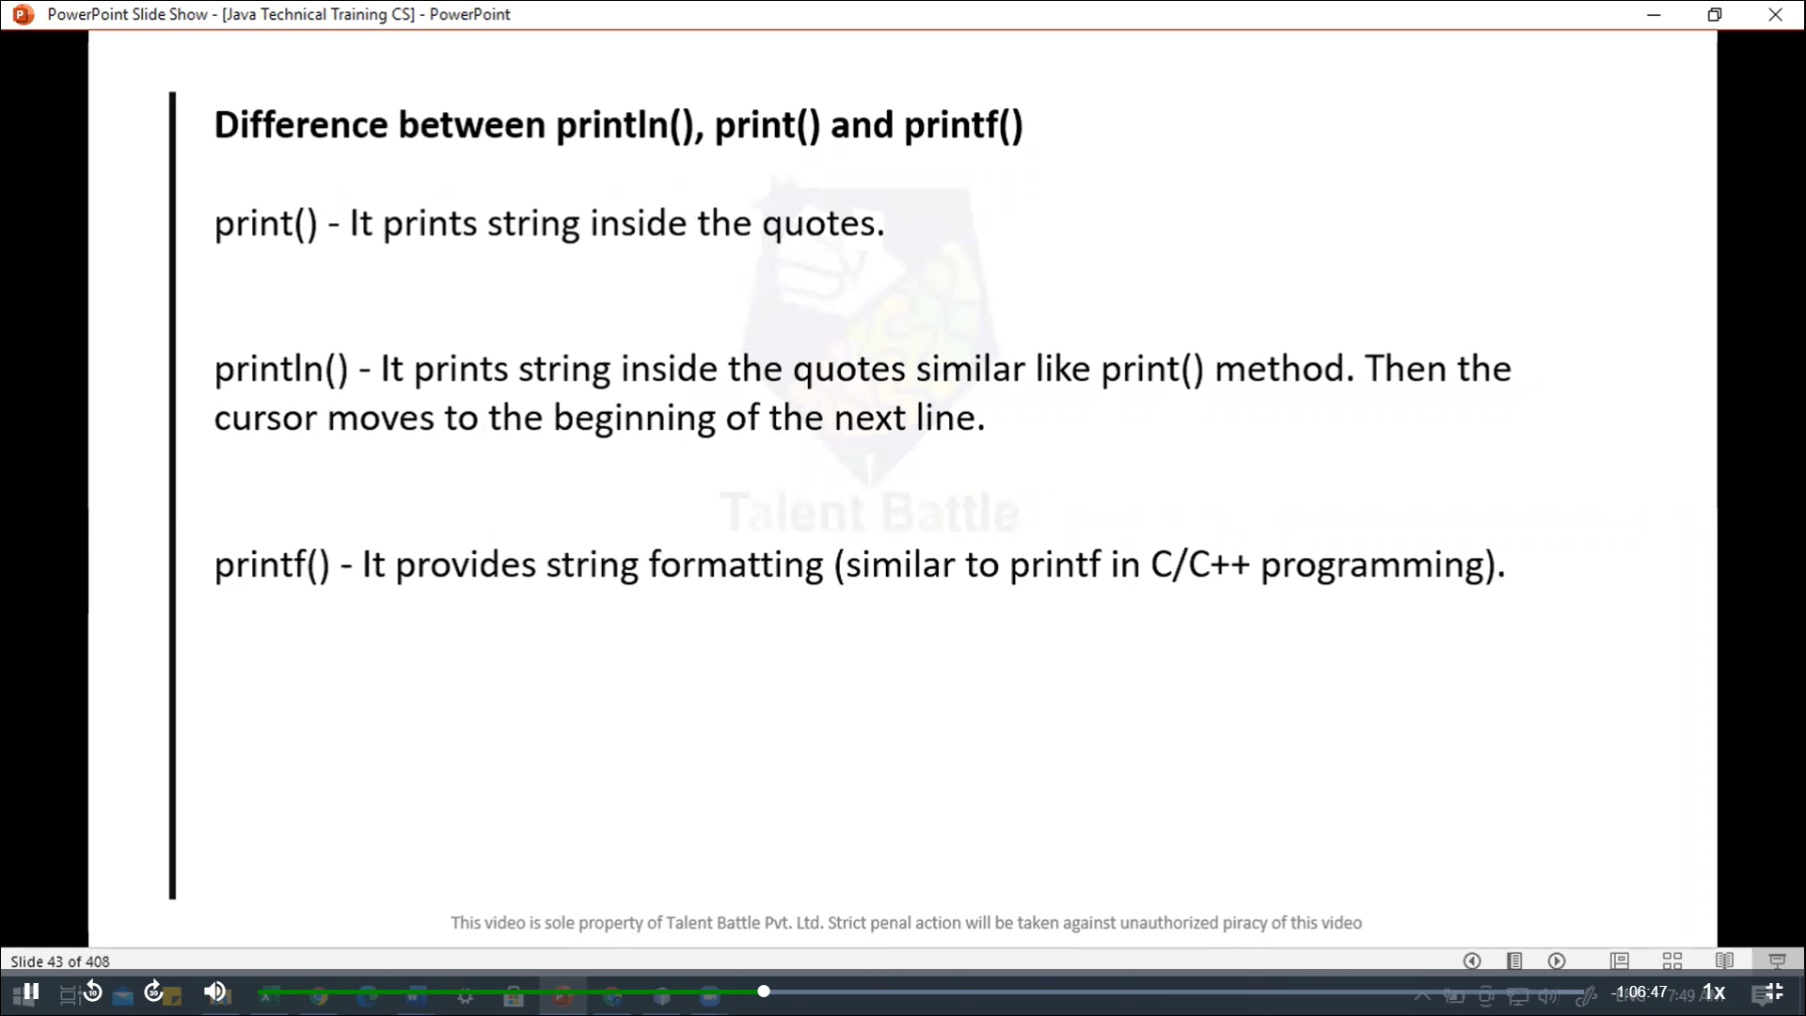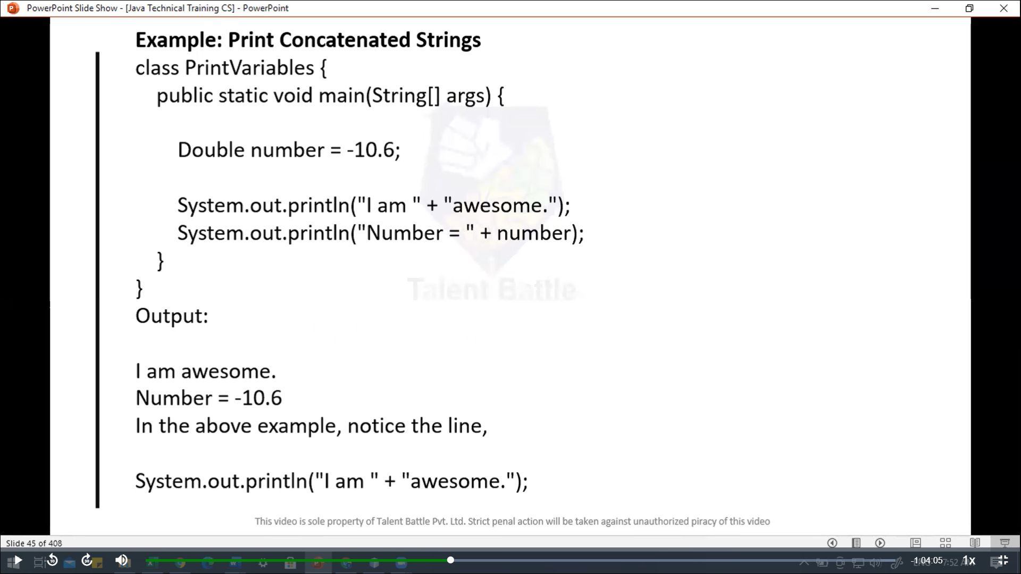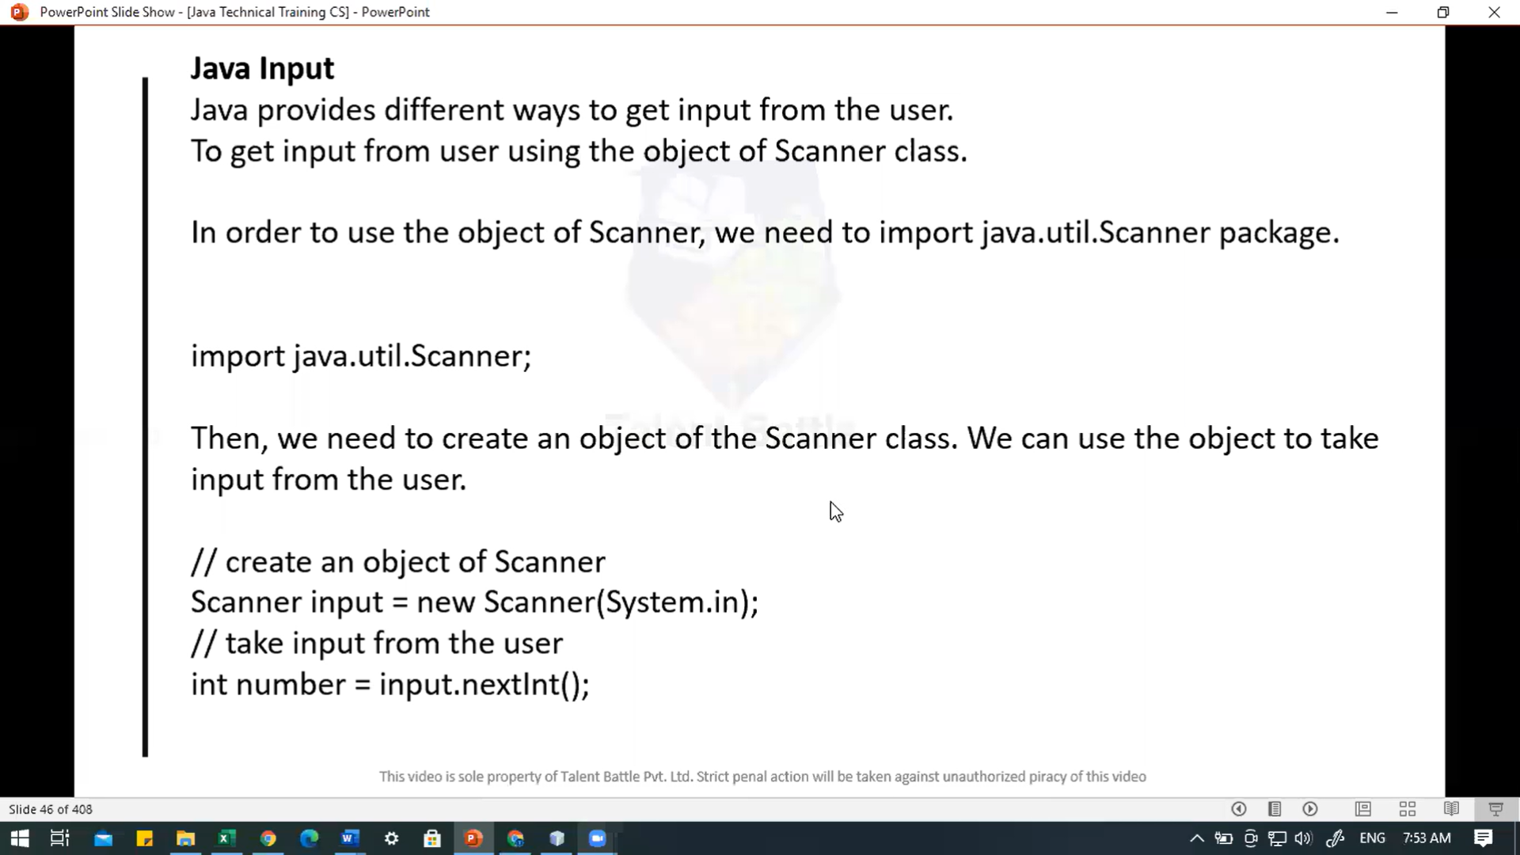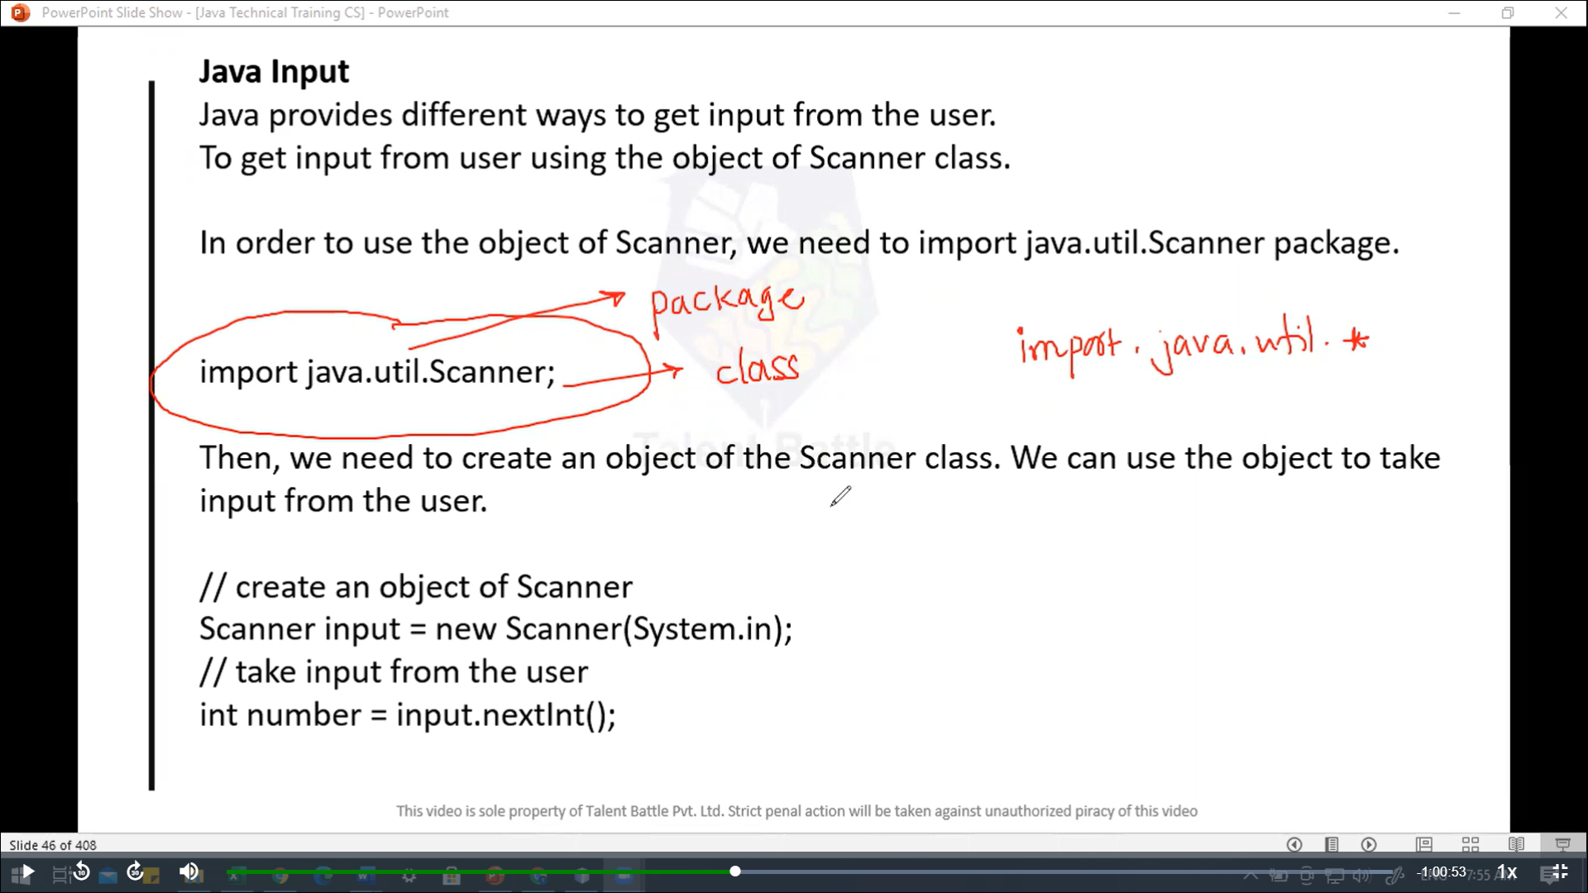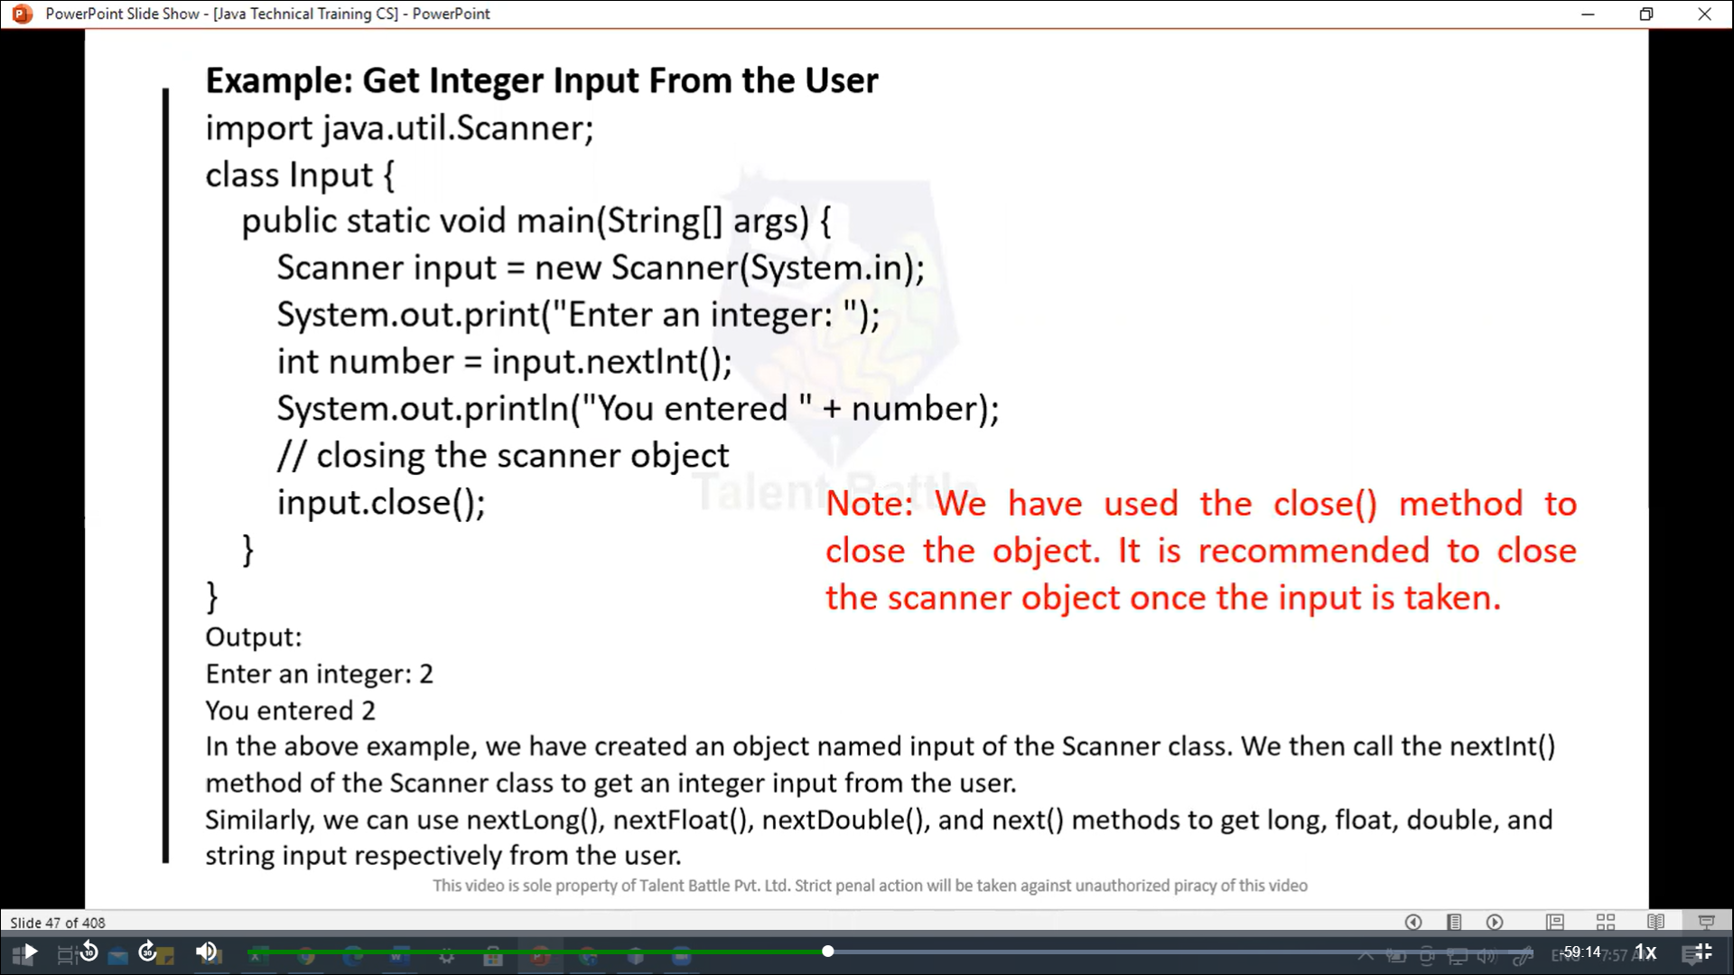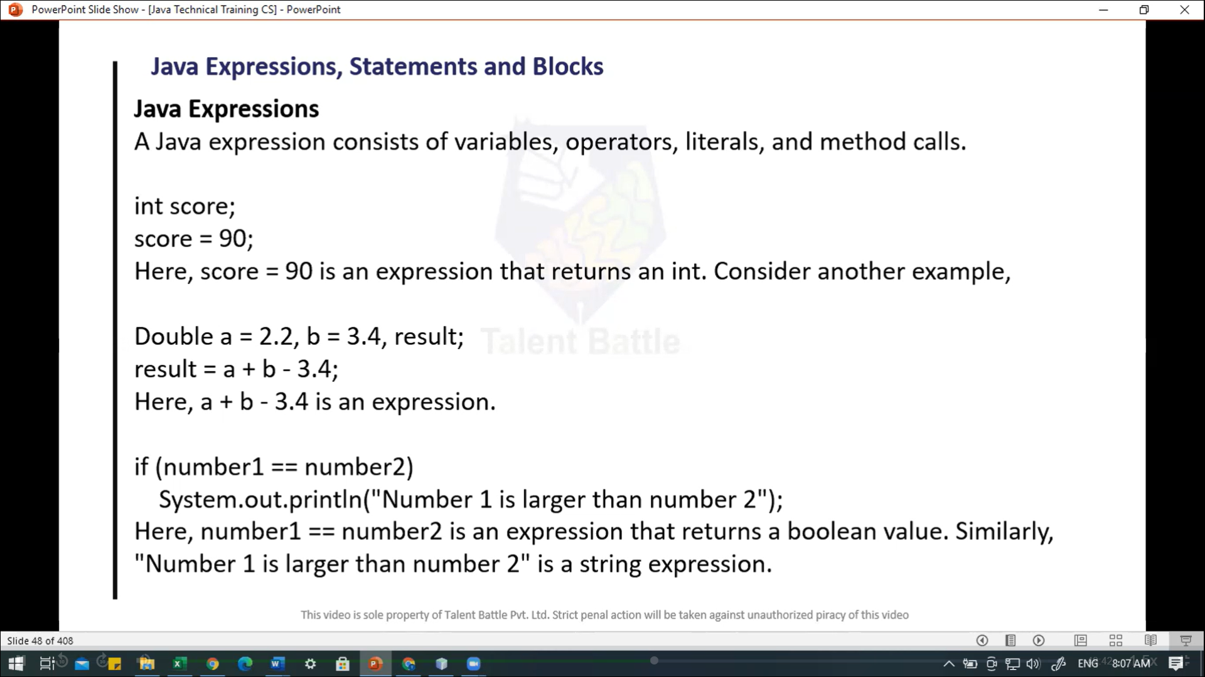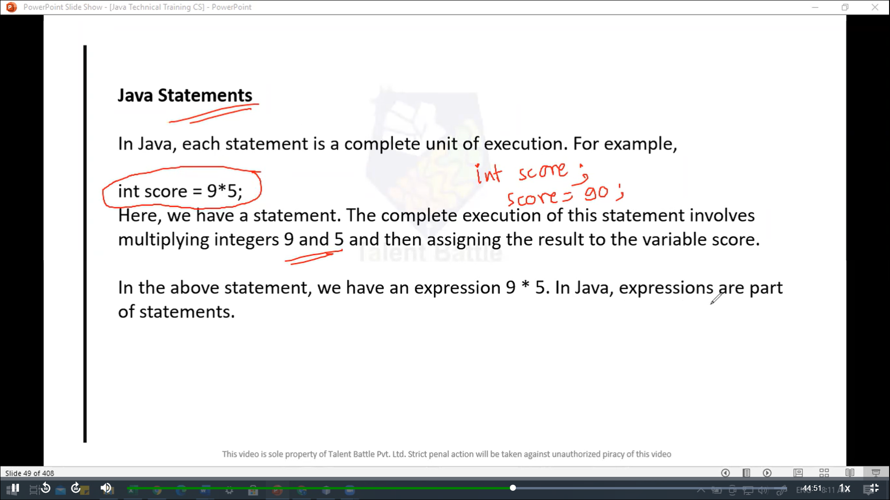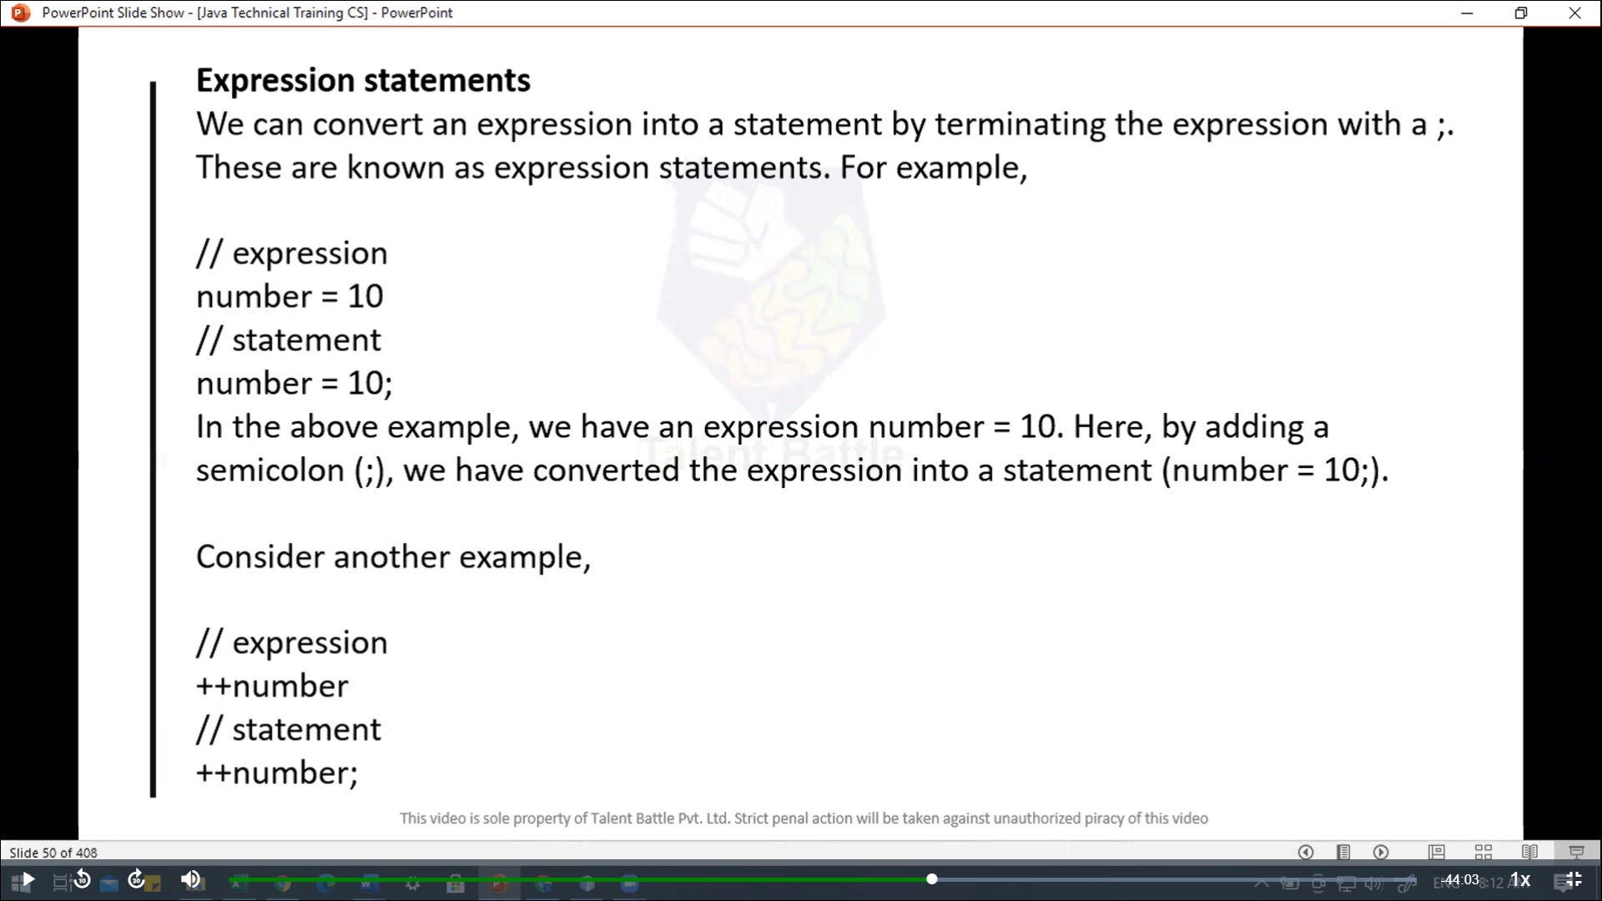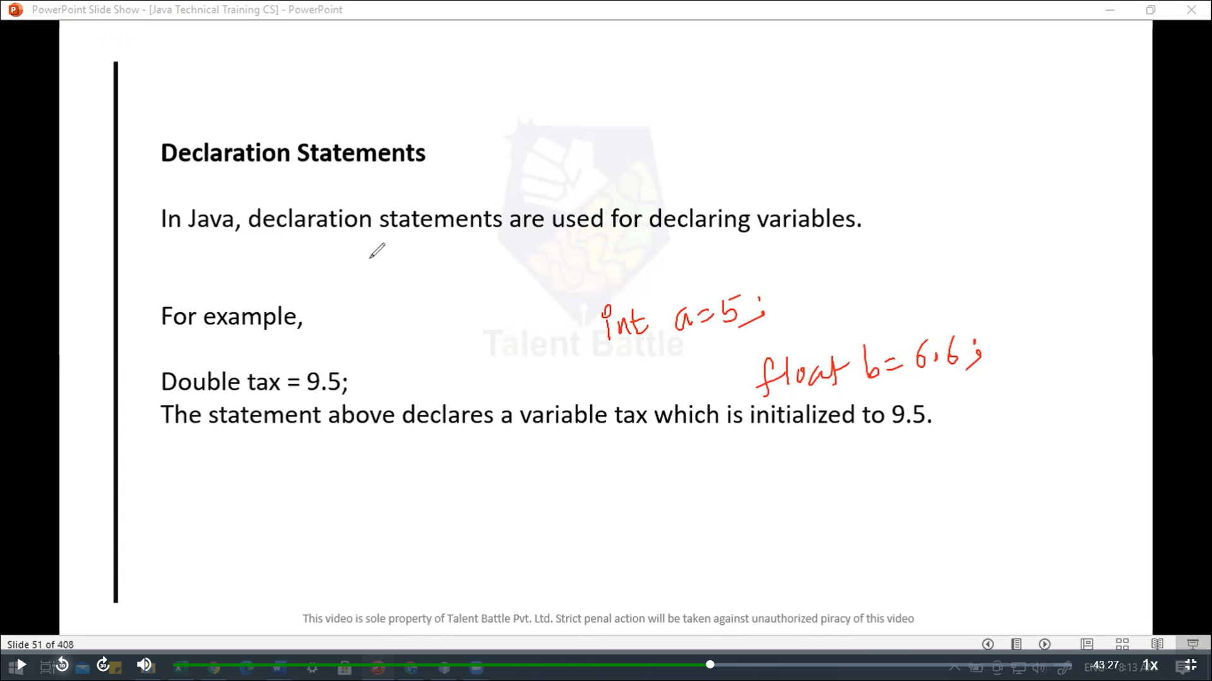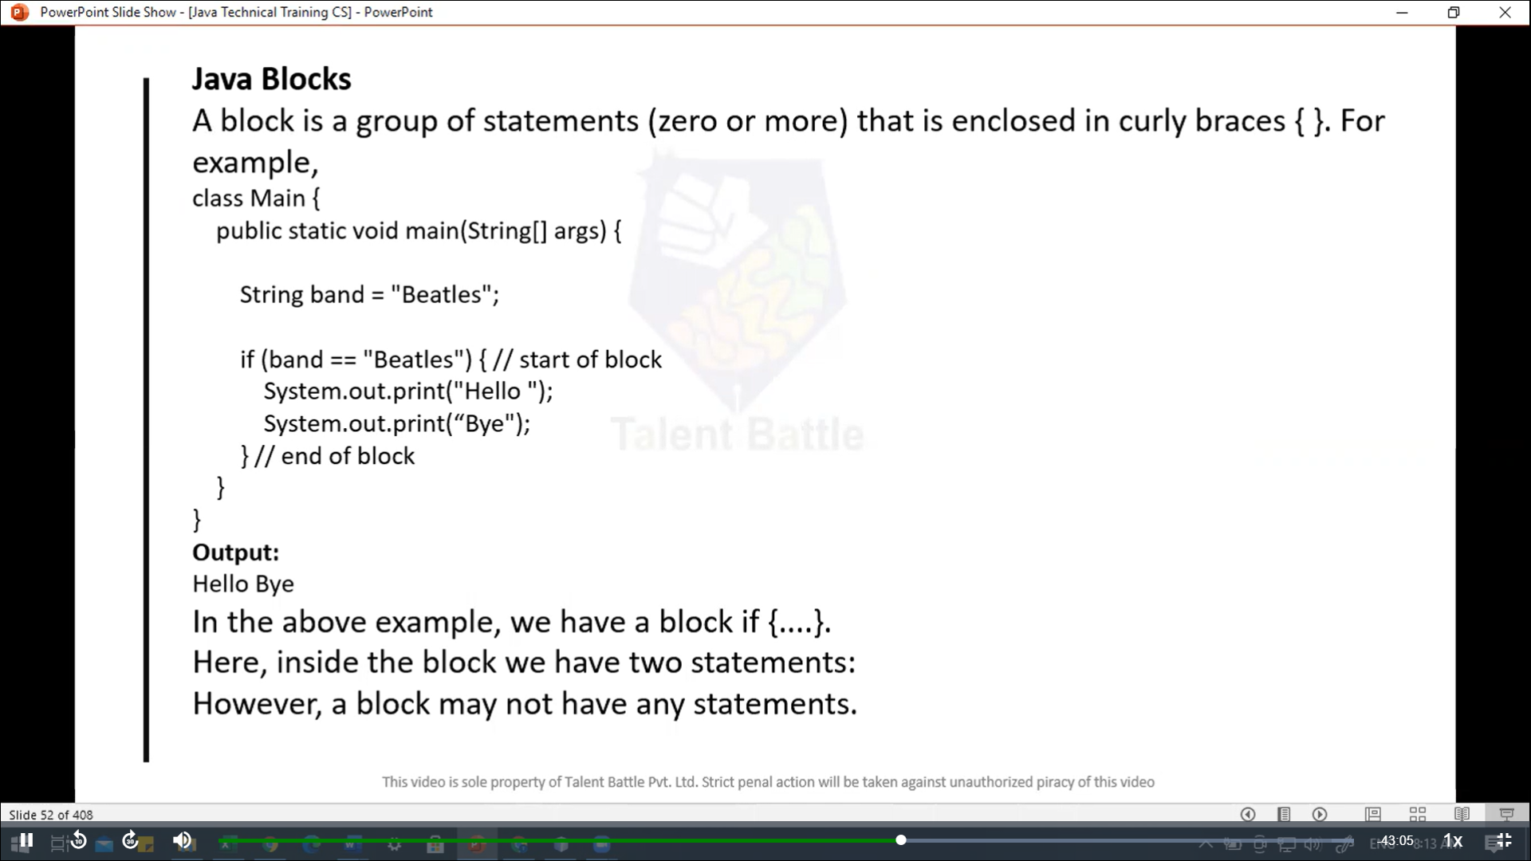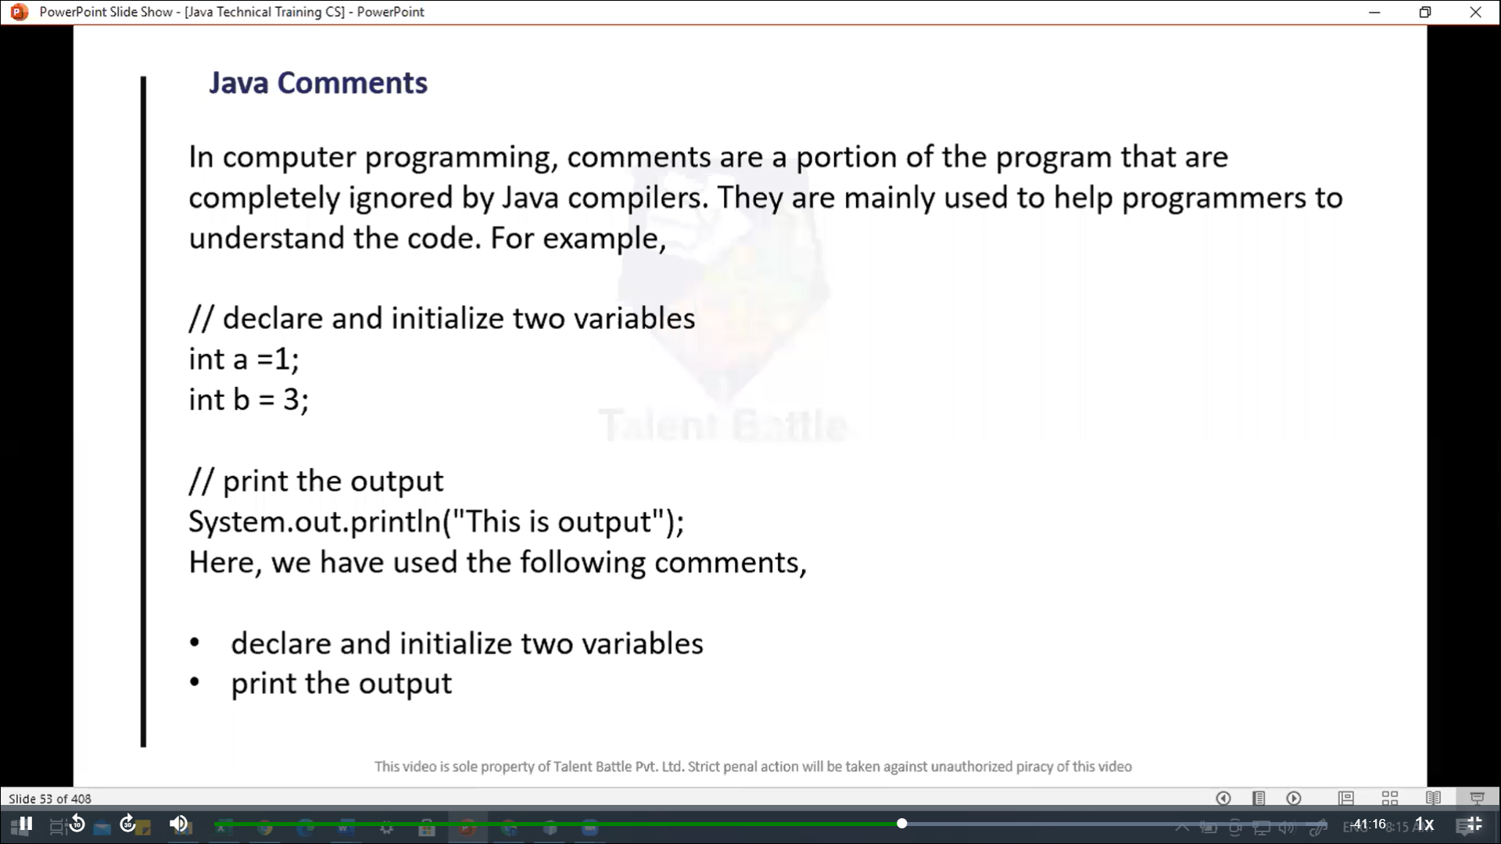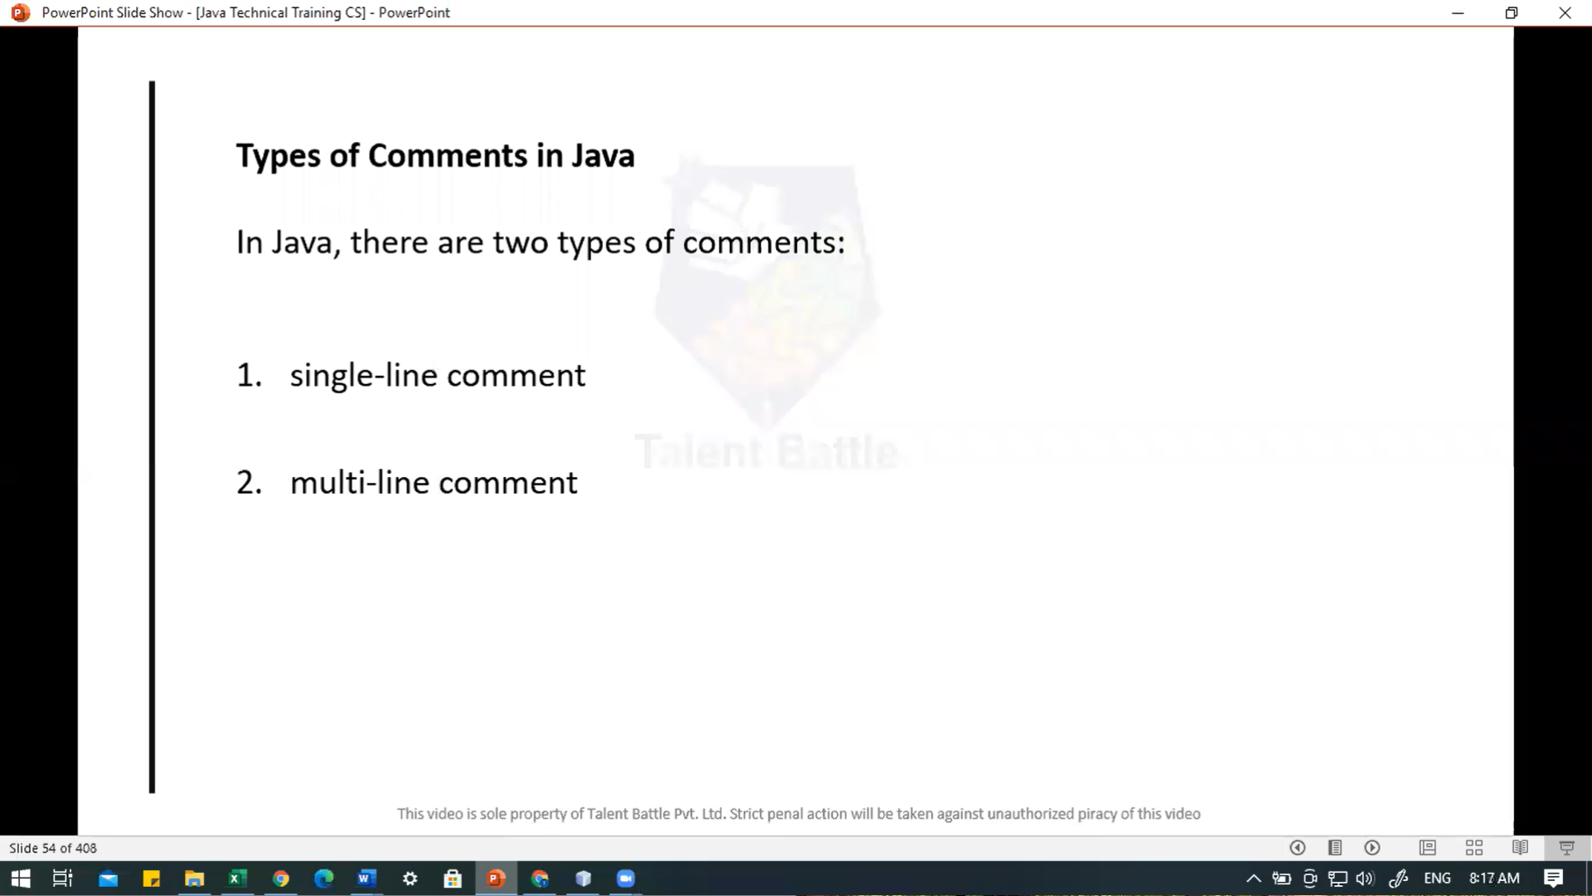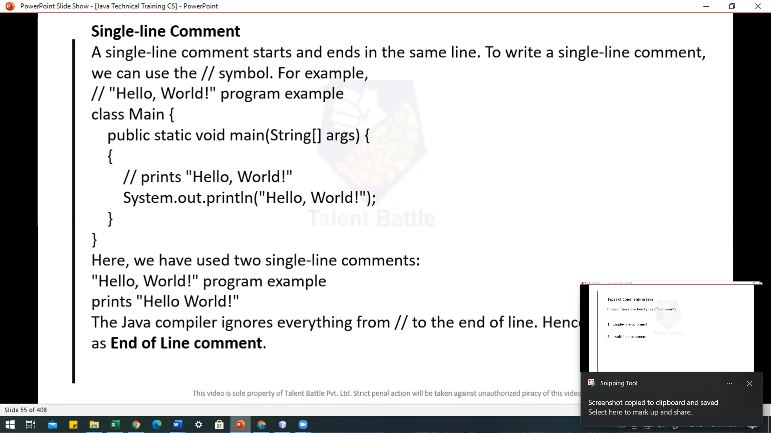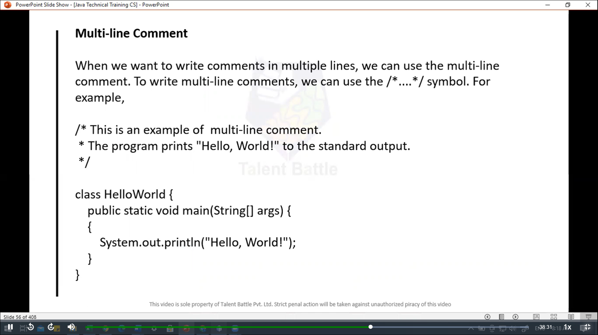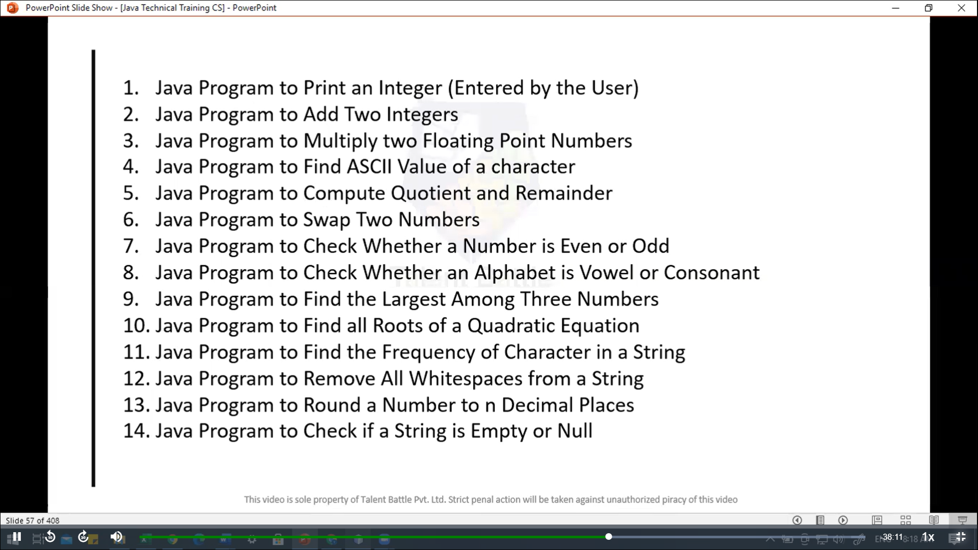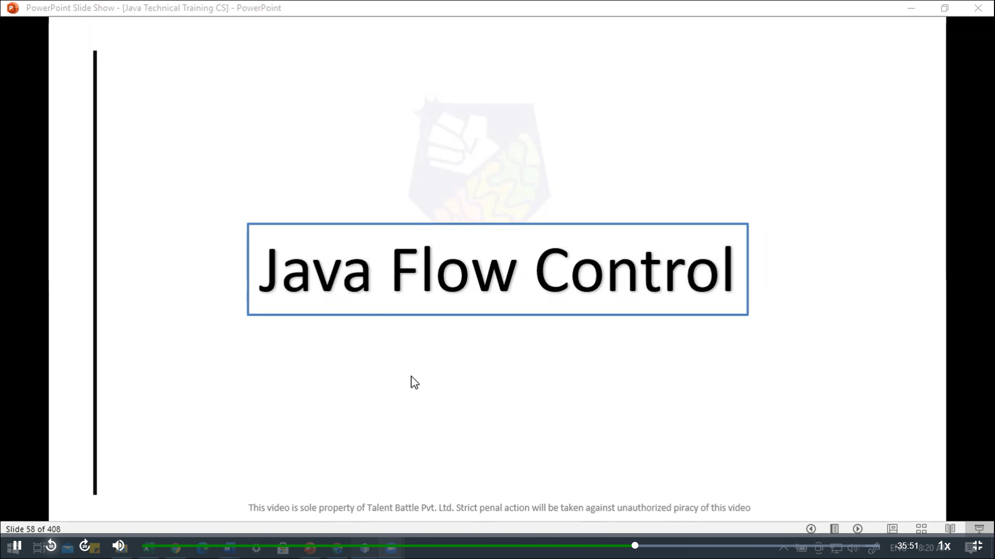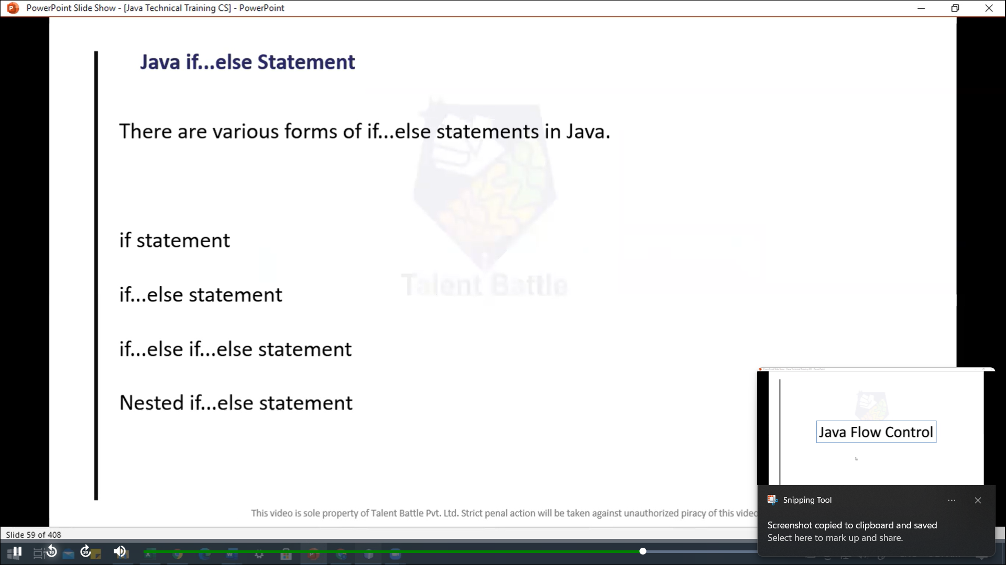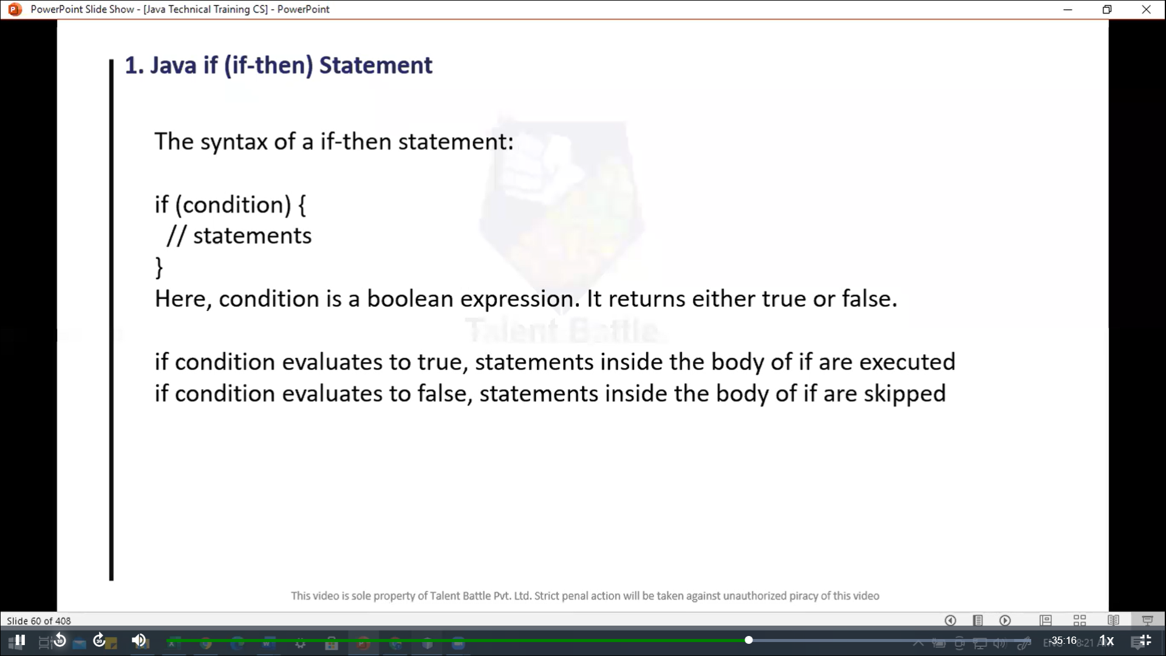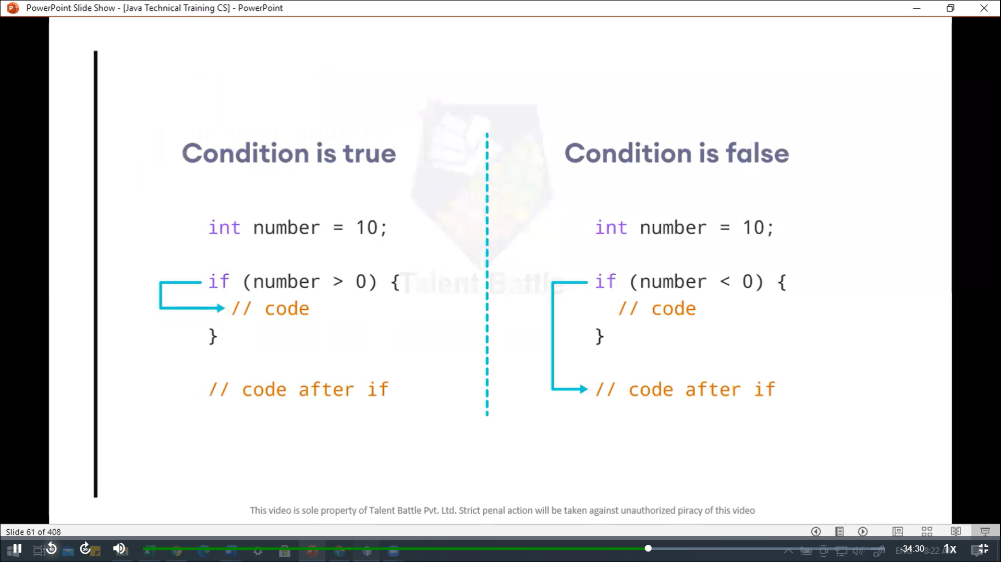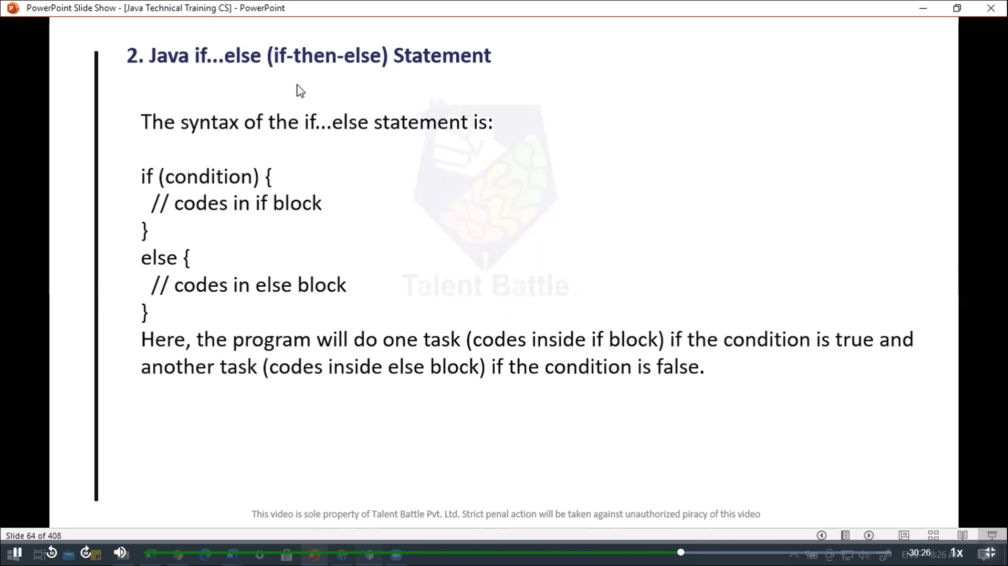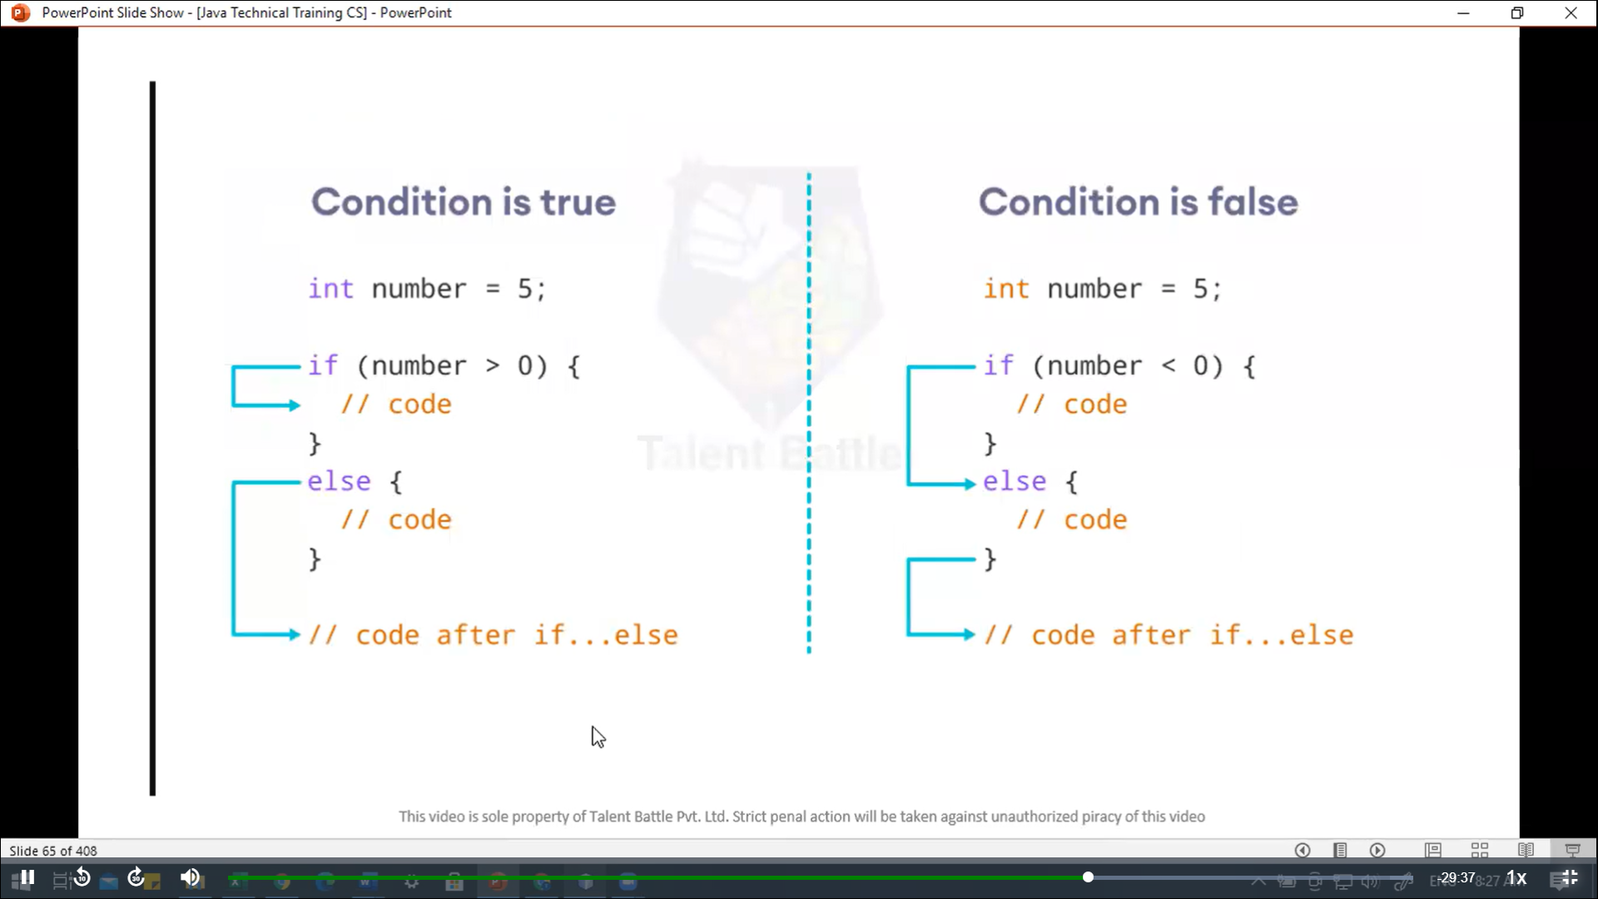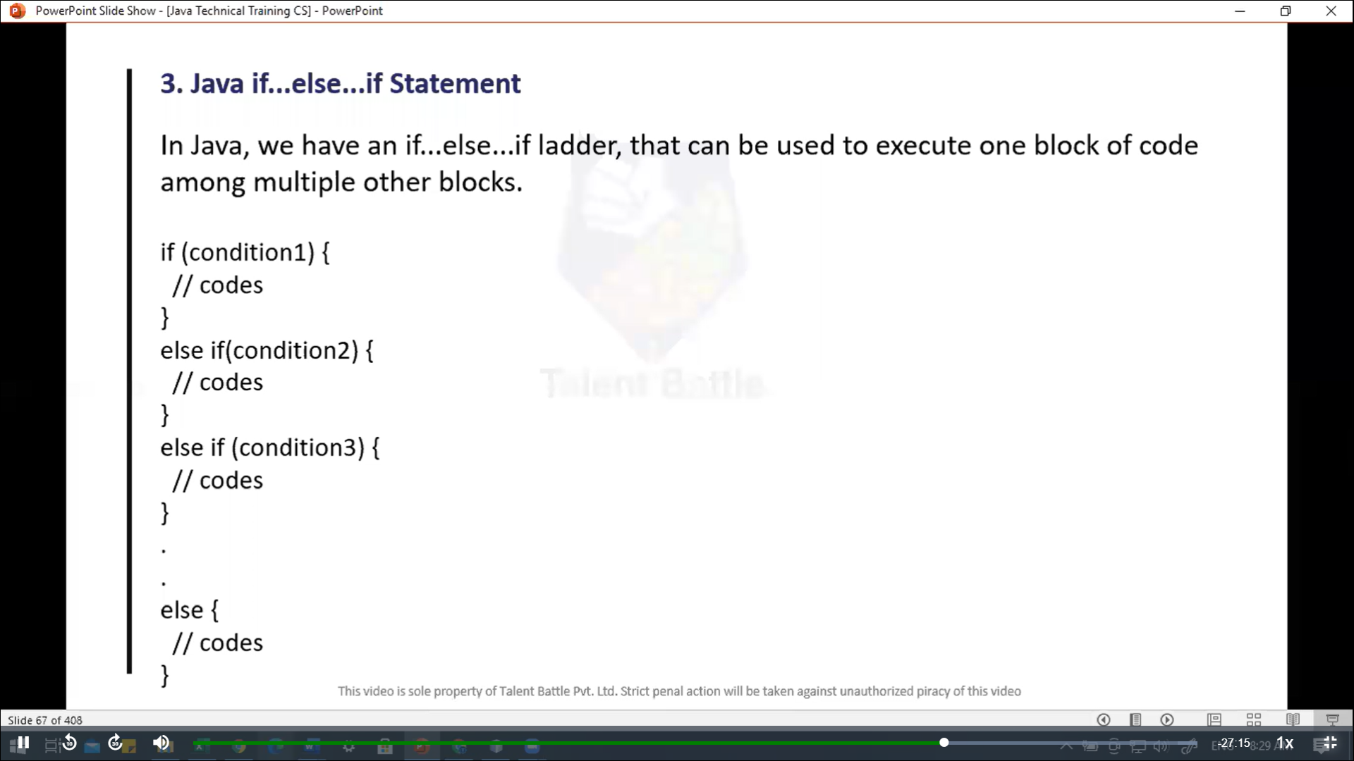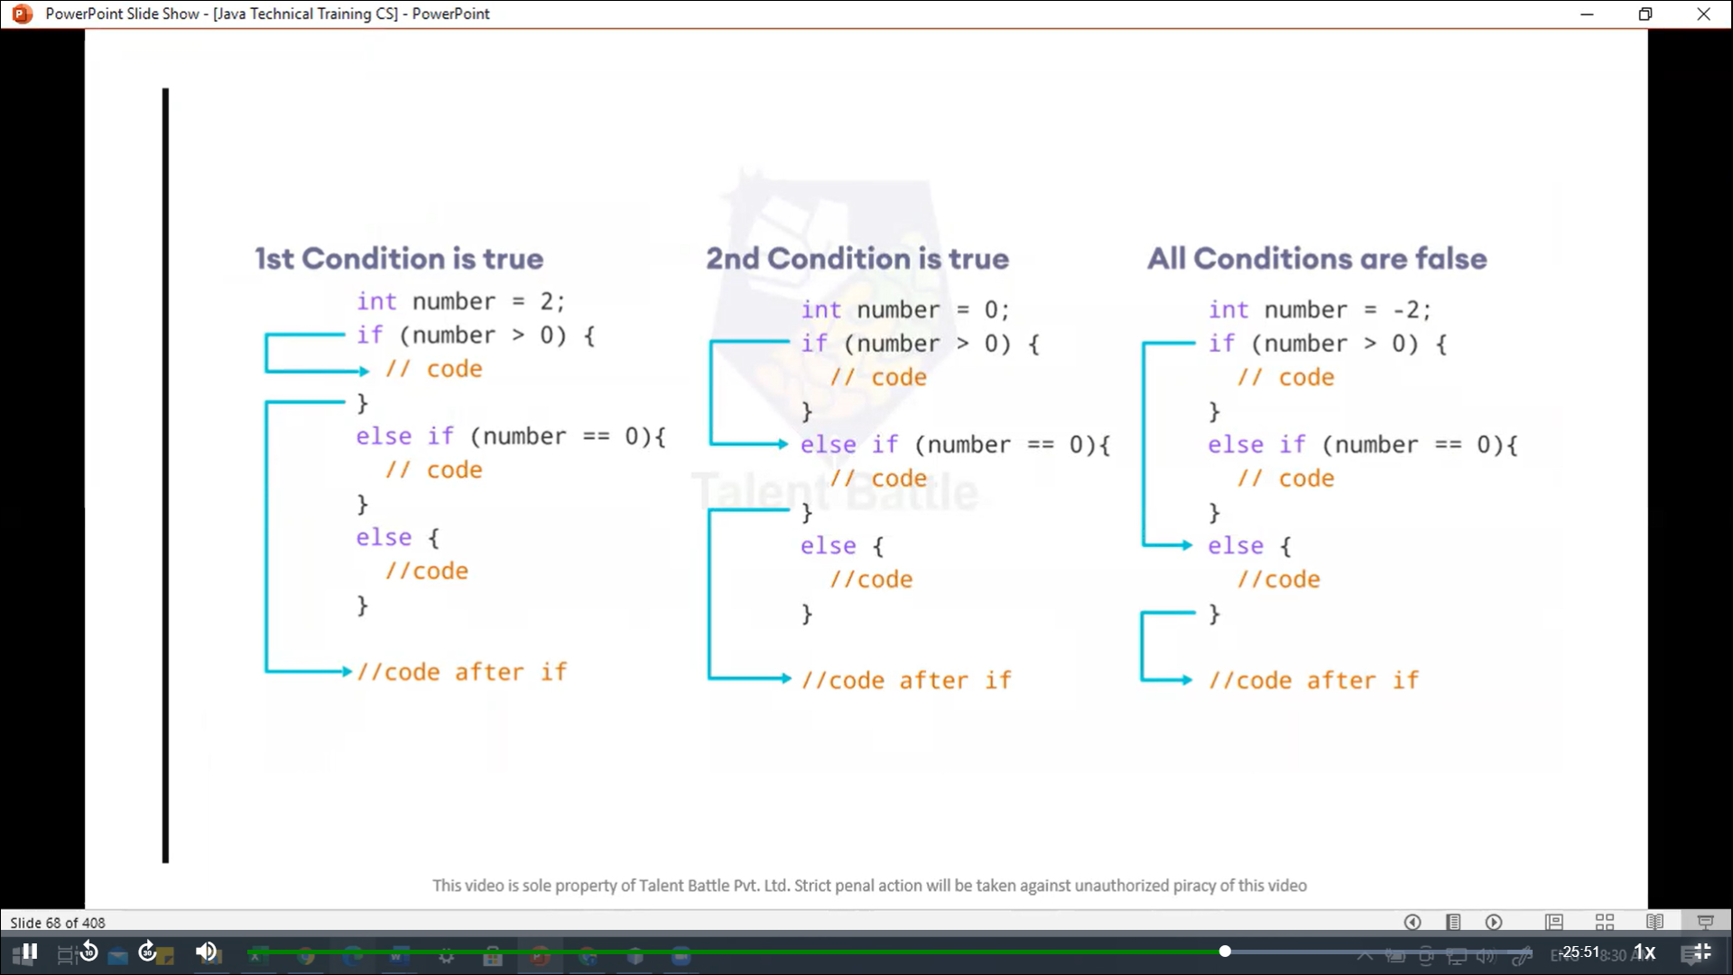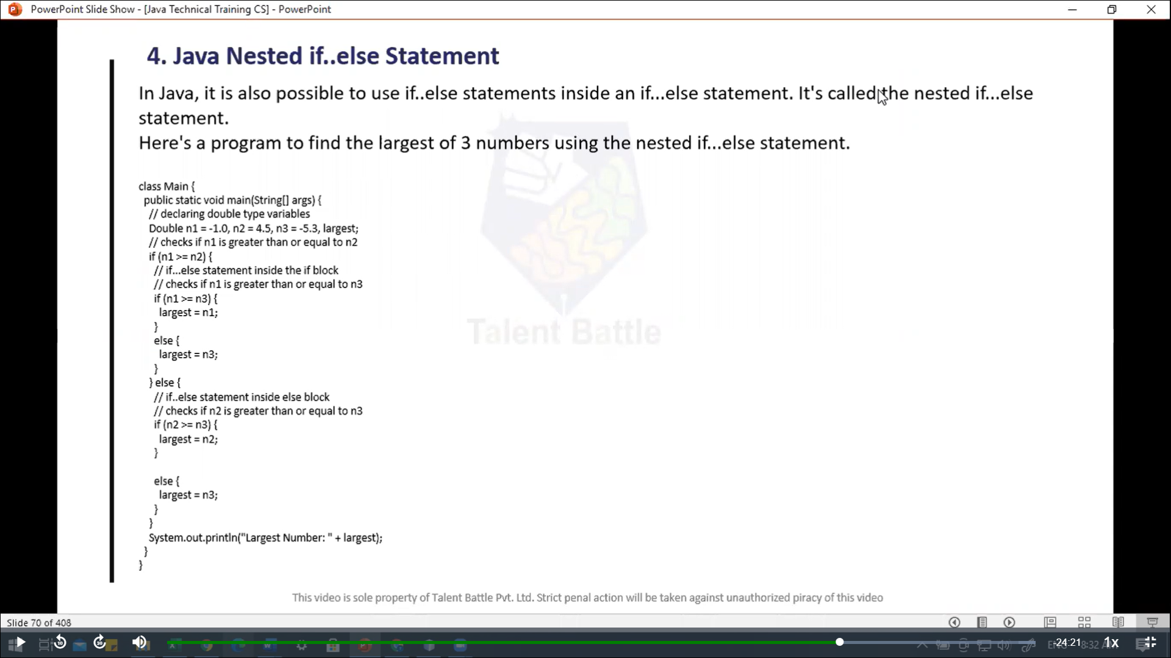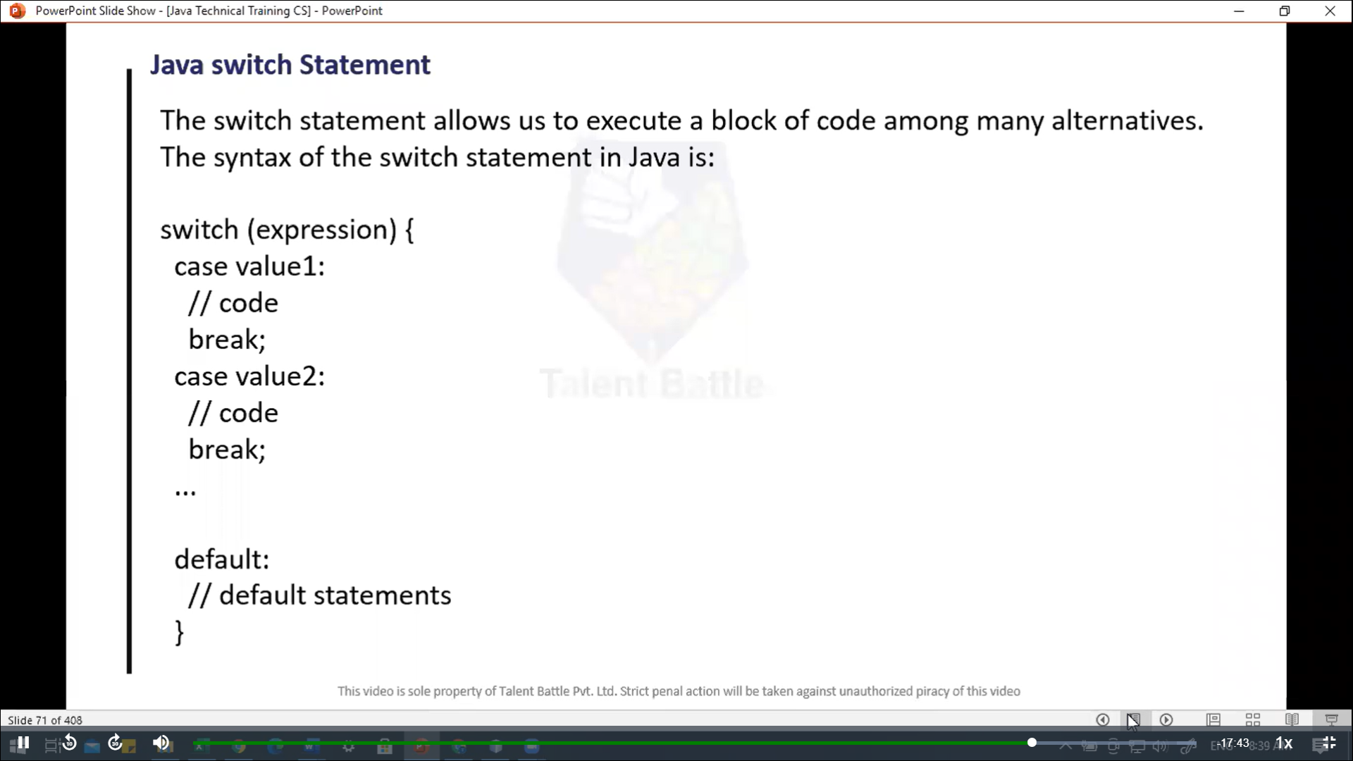

// Instanceof Operator :

//        The instanceof operator checks whether an object is an instanceof a particular class.

/**

 * Main

 */

public class Main {

  public static void *main*(String[] ***args***){

    String str = "Programming"***;***

    boolean result***;***

    // checks if str is an instance of

    // the String class

    result = str instanceof String***;***

    System***.***out***.****println*("Is str an object of String? " + result)***;***

    // ternary operator

    result = str instanceof String ? **true** : **false*;***

    System***.***out***.****println*("Is str an object of String? " + result)***;***

    int februaryDay = 29***;***

    String result1***;***

    result1 = (februaryDay == 28) ? "Not a leap year" : "Leap year"***;***

    System***.***out***.****println*(result1)***;***

    // printing variables and literals

    double number = -10.6***;***

    System***.***out***.****println*(5)***;***

    System***.***out***.****println*(number)***;***

    System***.***out***.****println*("================= Concatenated Strings =======================")***;***

    System***.***out***.****println*()***;***

    // print Concatenated Strings

    Double numberDouble = -10.6***;***

    System***.***out***.****println*("Hello, I am " + "a programmer")***;***

    System***.***out***.****println*("The number is " + numberDouble)***;***

    System***.***out***.****println*("================= Java Blocks =======================")***;***

    System***.***out***.****println*()***;***

    String band = "Beatles"***;***

    if (band == "Beatles"){ // start of block

      System***.***out***.****println*("The Beatles are the best")***;***

      System***.***out***.****println*("By!")***;***

    }

  }

}

import java***.***util***.***Scanner***;***

public class Input {

  public static void *main*(String[] ***args***){

    Scanner input = **new** *Scanner*(System***.***in)***;***

    System***.***out***.****println*("Enter an integer: ")***;***

    int number = input***.****nextInt*()***;***

    System***.***out***.****println*("You entered: " + number)***;***

    // closing the scanner object

    input***.****close*()***;***

  }

}

public class control_flow {

  public static void *main*(String[] ***args***) {

    System***.***err***.****println*("================ Control Flow =====================")***;***

    System***.***err***.****println*()***;***

    /*

    // if statement

    int number = 10;

    // check if number is greater than 0

    if(number > 0){

      System.err.println("The number is positive.");

    }

    System.err.println("Statement outside if block");

    // create a string variable

    String languageString = "Java";

    // if statement

    if(languageString == "Java"){

      System.err.println("Best Programming Language...");

    }

       */

       /*

      // if-else

      int number = 10;

      // check if number is greater than 0

      if(number > 0){

        System.err.println("The number is positive.");

      }

        // execute this block

        // if number is not greater than 0

        else{

          System.err.println("The number is not positive.");

        }

        System.err.println("Statement outside if...else block");

       */

       /*

       // if-else ladder

       int number = 10;

       // checks if number is greater than 0

       if(number > 0){

        System.err.println("This number is positive");

       }

       // check if number is less than 0

       else if(number < 0){

        System.err.println("This number is negative");

       }

       // if both condition is false

       else{

        System.err.println("This number is 0.");

       }

         */

         /*

      // Nested if..else statement

      Double n1 = -1.0, n2 = 4.5, n3 = -5.3, largest;

      // checks if n1 is greater than or equal to n2

      if(n1 >= n2){

        // if..else statement inside the block

        // check if n1 is greater than or equal to n3

        if(n1 >= n3){

          largest = n1;

        }

        else{

          largest = n3;

        }

      }

      else{

        // if..else statement inside else block

        // check if n2 is greater than or equal to n3

        if(n2 >= n3){

          largest = n2;

        }

        else{

          largest = n3;

        }

      }

      System.err.println("The largest number is " + largest);

      */

  // java program to check the size using the switch..case statement

  int number = 44***;***

  String size***;***

  // switch statement to check size

  switch (number) {

    case 29:

      size = "Small"***;***

      break***;***

    case 42:

      size = "Medium"***;***

      break***;***

    // match the value of week

    case 44:

      size = "Large"***;***

      break***;***

    case 48:

      size = "Extra Large"***;***

      break***;***

    default:

      size = "Invalid"***;***

      break***;***

  }

  System***.***err***.****println*("The size of the number is " + size)***;***

  }

}